File Submission:

For this homework, each exercise needs to be submitted in the following format, i.e. all exercises and required files in its own folder. These folders need to zipped in one folder called LastName_File_Activities.zip and submitted. Follow the screenshot below.

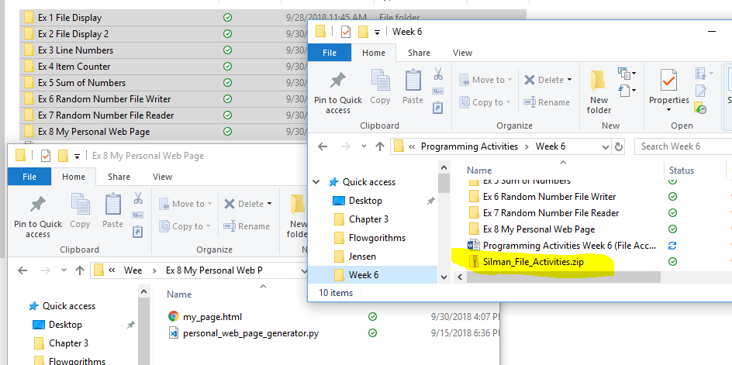

Exercise 1: Employee Data

Write a class named Employee that holds the following data about an employee in attributes: name, ID number, department, and job title.

Create a program that stores Employee objects in a dictionary. Use the employee ID number as the key. The program should present a menu that lets the user perform the following actions:

* Look up an employee in the dictionary
* Add a new employee to the dictionary
* Change an existing employee’s name, department, and job title in the dictionary
* Delete an employee from the dictionary
* Quit the program

When the program ends, it should pickle the dictionary and save it to a file. Each time the program starts, it should try to load the pickled dictionary from the file. If the file does not exist, the program should start with an empty dictionary.